# Recycling Mattresses in Asia

## Introduction

With the technology development for recycling mattresses and it’s various components, it is time to geographically expand this business. Given the amount of mattresses being produced and sold in Asia (APAC) it makes sense to look into this market to make that expansion. Taken the learnings from European countries, a quick start-up is possible.

## What is needed?

The components of making this business a success are:

1. Financial sound business model
2. Adequate technology, process and people
3. Market availability and readiness

## Business Model

The business model is based on creating a sustainable, circular mattress manufacturing process.

The mattresses are gathered from the consumers dumping them in the garbage. To secure these a gathering service, dump location and general knowledge to the public needs to be in place or put in place. The collection can be financed through the disposal fee which needs to be added or reserved by the mattress manufacturers. Learnings from Europe tell is this can be around 5-6 Euro per mattress. In addition the second main revenue stream will be the sales of recycled materials.

In addition foam waste material (trimfoam) from foam manufacturers or converters can be added to the volume. Right now most of this material is ending up as landfill.

The recycling of mattresses requires the following technologies:

1. Shredding of steel Existing in Asia
2. Recycling textile Existing in Asia
3. Generating repolyol Not yet existing in Asia
4. Rebonding foam Existing in Asia (but for own usage)
5. Shredding of foam as filling Existing in Asia on a small scale

To facilitate the business model, the company must actively engage with the customers to support the usage of recycled materials in their production process. Especially for the usage of repolyol as this would require additional technology for the customers to implement.

## Supply Chain Collaboration

**The integration of the different companies into an integrated collaborating supply chain will be the main unique selling point of this concept**. Working together with the various links in the value chain will enable the circular process and therefore create a sustainable mattress supply chain in Asia.

The amount of mattresses now going into landfill or incineration for all of South East Asia is as follows:

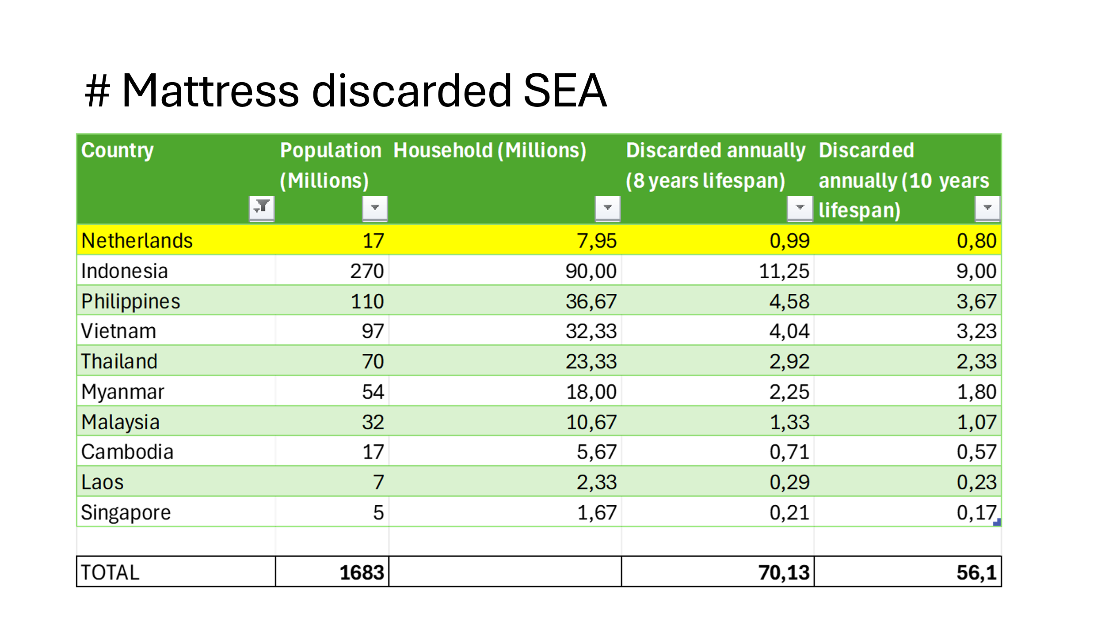

Even if the lifespan is around 10 years, the total amount is huge and more than enough to facilitate the business model. As a reference I have mentioned the Netherlands where at least 2 companies are operating on this business model for the last 10-15 years already.

### Circular Mattress Supply Chain Processes

The circular mattress supply chain is realized as follows:

1. The mattress manufacturers are selling the mattress through the following distribution channels:
   1. Own shops: usually branded mattresses
   2. On-line: the manufacturer has its own brand
   3. Large retail chains: Either as part of the collection or as a SIS (shop-in-shop) concept.
2. After the lifespan of the mattress has finished, the consumer buys a new mattress and disposes of the old mattress. Disposing of mattresses is a point in the supply chain where a new type of collection process needs to be put in place. Currently there are various disposal methods currently existing:
   1. The shop or retail chain takes back the mattress and offers the customer a discount to hand in their old mattress
   2. The consumer disposes of the mattress at a garbage collection point, or leaves it at his front door to be collected
   3. Illegal dumping of the mattress

Obviously the latter is not what we want to have, therefore we need to ensure new more adequate collection methods are in place. In addition we need to stimulate the retail shops/chains to expand the disposal method as mentioned here above under item a.

The new collection method would be to set-up collection points with special containers to ensure the mattress is kept dry. Using press containers will increase the efficiency enormously since one normal container can hold around 80 mattresses, but with compression it can go up to 400-480 mattresses.

1. All collected mattresses are being brought back to a factory/warehouse where the following processes are being performed:
   1. Sorting by type of mattress, and ensuring the mattresses are dry.
   2. Separating by type of material (raw materials) and suitability by finished product:
      1. Textile
      2. Springs
      3. Foam
      4. Rest (glue residual, and any other not mentioned here above)
   3. Value adding to the raw material
      1. Shredding of textile, or compacting to reduce transport cost;
      2. Shredding of springs, or compacting to reduce transport cost;
      3. Shredding of foam for further processing;
      4. Assembling rest materials for incineration.
   4. Creating new products/finished goods
      1. Textile: Moreloop model
      2. Steel
      3. Bonded foam
      4. Repolyol
2. All finished goods are sold to be input for new (mattress) products and thus creating the circular supply chain.
   1. Textile to be upcycled and/or used for non-woven/felt/yarn
   2. Steel to be re-used for new steel/metal products
   3. Bonded foam will be used for various products, including mattresses
   4. Repolyol will be blended with regular polyol and used in the foam production for new mattresses.

For a one-time collection of large garbage items, the BMA will charge 125 baht for less than 500 litres and another 130 baht for disposal. For garbage from 500 litres to less than 1 cubic metre, the collection fee is 180 baht and the disposal fee is 190 baht. For garbage bigger than 1 cubic metre, the collection fee is 245 baht per cubic metre and the disposal fee is 250 baht per cubic metre